Requirement ID
Title | Add/Invite Super Manager
User Story | - As a malaria toolkit WHO user, I want to add super manager so that this user will add other users for given country.
Actors/user lists | WHO User
Pre-condition | - WHO user successfully logs in into malaria toolkit application.
Description | - To add new super manager, WHO user will logs into application and select ‘User Management’ option from application dashboard.  - WHO user will then select ‘Add Super manager’ option.  - After clicking this, ‘Add Super manager’ pop up will open. If new user is already present in WHO Azure AD, then WHO user can search email address, select ‘Add’ option and new super manager will then be added into application database. Notification email will be send to newly added super manager along with link to log in. When newly added user clicks on it, user will be redirected to Azure authentication and log in using email and password.  - If new user is not in WHO AD then WHO user will fill information for following fields –  - Name*(100,char)  - Email Address*(256,char) (WHO user will be able to enter email address. Our team will not be validating the email address)  - Organization Name*(100,char) (Super manager can later change the organization name from profile section)  - Choose country to assign*(countries from master list of country)  - After filling up information for above fields, WHO user will select ‘Add’ to add new super manager and that new super manager details will be added into WHO Azure AD and application database.  - Invitation email will be send to newly added super manager on entered email address along with link log in into application.  - When newly added super manager clicks on that link, that user will be redirected to azure authentication where user can log in using same email (as in invitation email).  - WHO user will not be able to add two super managers with same email address.  - While selecting a country, WHO user can select only those countries for which super manager role was not previously assigned or countries whose super managers are not active.  - WHO user can cancel the process of adding new super manager by clicking on ‘Cancel’ option.  - Newly added super manager will be displayed in ‘Invitation not accepted’ status to WHO user in list of super managers. When newly added super manager logs in for first time into application, status of that super manager will change to ‘Active’ status in list of super manager.  - Name, Email address, Organization name, country and status columns will be displayed for list of super managers. Each of these columns has filter associated with it.
Post Condition | - Newly added super manager will be displayed in ‘Invitation not accepted’ or ‘Active’ status in the list of super managers.
Alternate flows | No.
Priority | 1
Special Requirements/notes

Requirement ID
Title | Add/Invite Viewer
User Story | - As a malaria toolkit super manager user, I want to add/accept viewer so that this user will view assessments and summary information for given country.
Actors/user lists | Super Manager
Pre-condition | - User has an access to malaria toolkit.
Description | - If viewer logs in for first time, viewer will fill out registration form from landing page of the application. Registration form will have following information to be filled –  - Name*(100,char)  - Email Address*(256,char) (viewer will enter email address. Our team will not be validating the email address)  - Organization Name*(100,char)  - Access for countries*(countries from master list of country)  - Viewer can later change organization name or request access for more countries from profile section.  - Once viewer request a country access that request will be sent to super manager for that country. Viewer can request access for multiple countries at a time.  - To add viewer, super manager will select ‘User Management’ option from application dashboard.  - Super manager will then select ‘Pending Request’ option.  - Super manager will view all the pending request submitted by different viewers.  - Super manager will then invite a viewer or reject the request of given user.  - If super manager invite a viewer, the viewer will be added into WHO Azure AD and application database. Also the viewer who has submitted the country request will get an invitation email on given email address. This invitation email will contain application link to log in.  - Newly added/invited viewer will be displayed in ‘Invitation not accepted’ status to super manager in list of users. When newly added/invited viewer logs in for first time into application, status of that user will change to ‘Active’ status in list of users.  - If super manager rejects the request, super manager will provide reason for rejection and notification email will be sent to respective viewer along with reason.  - Viewer who has got an access to a country will be able to view all assessments and summary information for that country.
Post Condition | - Newly added viewer will be displayed in ‘Invitation not accepted’ or ‘Active’ status in the list of users.
Alternate flows | No.
Priority | 1
Special Requirements/notes

Requirement ID
Title | Assign Manager role to viewer
User Story | - As a malaria toolkit super manager user, I want to add Manager so that this user will create assessments for given country.
Actors/user lists | Super Manager
Pre-condition | - User has an access to malaria toolkit.  - User with viewer role is present in the system
Description | - Super manager can assign manager role to given viewer.  - Viewer has to be in ‘Active’ status in list of users to assign him/her as manager.  - To add manager, super manager will select ‘User Management’ option from application dashboard.  - Super manager will then select viewer and assign a role as manager.  - Once assigned as manager, super manager will not be able to change role from manager to viewer.  - The viewer whose role has been changed to manager will get a notification email.
Post Condition | - Newly assigned manager will be displayed in list of users in ‘User Management’ section of super manager.
Alternate flows | No.
Priority | 1
Special Requirements/notes | Wireframe : Title – Usermanagement/ForSupermanager  https://www.figma.com/file/0Nj6oi5rJtQ7aUVcaxyYD9/WHO-MALARIA?node-id=1592%3A0

Requirement ID
Title | Activate/deactivate Super Manager
User Story | - As a malaria toolkit WHO user, I want to Activate/deactivate existing super manager so that I can provide access to required users.
Actors/user lists | WHO User
Pre-condition | - User has an access to malaria toolkit.  - Super manager has already been added into the application.
Description | - When super manager logs in into the application for first time, the status of that super manager is ‘Active’.  - WHO user can deactivate already active super manager by selecting ‘Deactivate’ option.  - Once deactivated, email notification will be sent to respective super manager.  - WHO user can activate previously deactivated super manager only if there is no other super manager in ‘Active’ status for that country as there will be only one super manager for given country.  - ‘There is an active Super Manager for this country’ message will be displayed if a super manager is already present and WHO user tries to activate previously deactivated super manager for same country.  - Once activated, email notification will be sent to super manager.  - Following text will be displayed in the notification email–  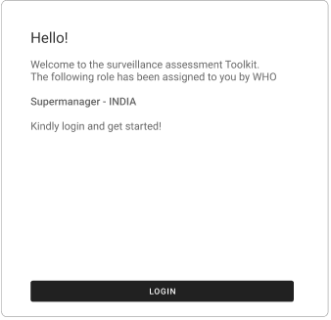
Post Condition | - Active super manager will be displayed with ‘Active’ status in the list of super manager.  - Deactivated super manager will be displayed with ‘Inactive’ status in the list of super manager.
Alternate flows | No.
Priority
Special Requirements/notes | Wireframe : Title – Usermanagement/ForWHOusers  https://www.figma.com/file/0Nj6oi5rJtQ7aUVcaxyYD9/WHO-MALARIA?node-id=1592%3A0

Requirement ID
Title | Activate/deactivate Viewer
User Story | - As a malaria toolkit super manager, I want to Activate/deactivate existing viewer so that I can provide access to required users.
Actors/user lists | Super Manager
Pre-condition | - User has an access to malaria toolkit.  - Viewer has already been added into the application.
Description | - When viewer logs in into the application for the first time, the status of that viewer is ‘Active’.  - Super manager can deactivate already active viewer by selecting ‘Deactivate’ option.  - Once deactivated, email notification will be sent to respective viewer.  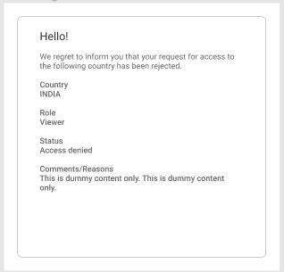  - When this viewer tries to login, “This user is deactivated” message will be displayed. If viewer requested access for multiple countries, rejected countries will be displayed on dashboard along with reason.  - Super manager can activate previously deactivated viewer  - Once activated, email notification will be sent to viewer with login link -  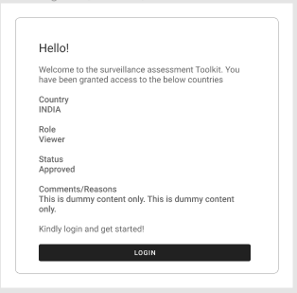
Post Condition | - Active viewer will be displayed with ‘Active’ status in the list of users.  - Deactivated viewer will be displayed with ‘Inactive’ status in the list of users.
Alternate flows | No.
Priority
Special Requirements/notes | Wireframe : Title – Usermanagement/ForSupermanager  https://www.figma.com/file/0Nj6oi5rJtQ7aUVcaxyYD9/WHO-MALARIA?node-id=1592%3A0  Viewer Access  https://www.figma.com/file/0Nj6oi5rJtQ7aUVcaxyYD9/WHO-MALARIA?node-id=1592%3A0

Requirement ID
Title | Activate/deactivate Manager
User Story | - As a malaria toolkit super manager, I want to Activate/deactivate existing manager so that I can provide access to required users.
Actors/user lists | Super Manager
Pre-condition | - User has an access to malaria toolkit.  - Manager has already been added into the application.
Description | - When manager role is assigned to a viewer into the application, the status of that manager is ‘Active’.  - Super Manager can deactivate already active manager by selecting ‘Deactivate’ option.  - Once deactivated, email notification will be sent to respective manager.  - When this manager tries to login, “This user is deactivated” message will be displayed.  - Super manager can activate previously deactivated manager  - Once activated, email notification will be sent to manager with login link.
Post Condition | - Active manager will be displayed with ‘Active’ status in the list of users.  - Deactivated manager will be displayed with ‘Inactive’ status in the list of users.
Alternate flows | No.
Priority
Special Requirements/notes | Wireframe : Title – Usermanagement/ForSupermanager  https://www.figma.com/file/0Nj6oi5rJtQ7aUVcaxyYD9/WHO-MALARIA?node-id=1592%3A0  Manager role assigned  https://www.figma.com/file/0Nj6oi5rJtQ7aUVcaxyYD9/WHO-MALARIA?node-id=1592%3A0

